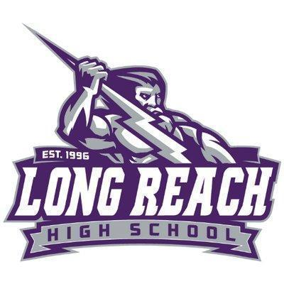
2026 PTSA SENIOR SCHOLARSHIP PROGRAM
OVERVIEW

The Long Reach High School PTSA is pleased to announce our annual Senior Scholarship Program. Applications are now being accepted and $500.00 awards are available to seniors from the class of 2026. Winners will be notified and awarded scholarships at the LRHS Senior Awards Ceremony. GPA will not be a factor in this scholarship program. Selection criteria is based on fully answering the essay question below. Essays will be judged on content, organization, grammar, clarity, and originality.

ELIGIBILITY CRITERIA

- Must be a current member of the LRHS PTSA as of March 31, 2026. To become a member, go to https://lrhs-ptsa.givebacks.com/shop to register/pay online or contact our membership lead at president@lrhsptsa.org for other payment options.
- Must be a 2026 LRHS graduating senior.
- Must be accepted to a college (2 or 4 year), art school, trade/technical school or the military.

INSTRUCTIONS
- Complete the entire application. Incomplete applications will not be considered.
- Obtain your counselor’s signature or an email from your counselor to confirm your eligibility, before submitting an application. If an email confirmation is obtained from your counselor, please forward the email along with your application submission.
- Typed responses to the required student essay questions (10-12 font / double spaced). Please save file as text PDF.
- Total response to the essay question must be 300 - 500 words.

SUBMISSION

- Application must be completed by the student.
- Submit complete application and essay responses via email to: scholarship@lrhsptsa.org
- Applications must be received no later than: Tuesday, April 7, 2026.
2026 PTSA SENIOR SCHOLARSHIP APPLICATION
Deadline: Tuesday, April 7, 2026

Applicant Information:
Last Name | First Name | Middle Initial
Phone | E-Mail Address
I authorize LRHS Student Services/school counselor to confirm my post high school status for scholarship eligibility.

Student Signature: Date
Has the student been admitted to a 2 or 4 year college, university, arts or trade school for the 2025-2026 school year?
Yes No If yes,

Name of college/school planning to attend: Counselor’s Signature: Date:
Attach your typed response to the question below:

How has your involvement in LRHS or similar community-based organizations shaped who you are, the impact you’ve had on your school or local community, and the way you hope to contribute in college or your future career?

**Response must be 300 - 500 words, 10-12 font, double spaced.
Please save file as a text PDF

