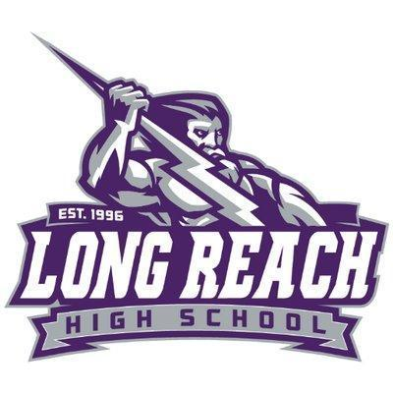
2024 PTSA SENIOR SCHOLARSHIP PROGRAM
OVERVIEW

The Long Reach High School PTSA is pleased to announce our annual Senior Scholarship Program. Applications are now being accepted and $500.00 awards are available to seniors from the class of 2024. Winners will be notified and awarded scholarships at the LRHS Senior Awards Ceremony. GPA will not be a factor in this scholarship program. Selection criteria based on fully answering the essay questions and on creativity/originality.

ELIGIBILITY CRITERIA

- Must be a current member of the LRHS PTSA as of March 31, 2024. To become a member, go to https://lrhs-ptsa.memberhub.store/store/items/91748 to register/pay online or contact our membership lead at membership@lrhsptsa.org for other payment options.
- Must be a 2024 LRHS graduating senior.
- Must be accepted to a college (2 or 4 year), art school, trade/military or technical school.

INSTRUCTIONS
- Complete the entire application. Incomplete applications will not be considered.
- Obtain counselor’s signature or email from counselor to confirm your eligibility, before submitting application. If an email confirmation is obtained from your counselor, please forward the email along with your application submission.
- Typed responses to the required student essay questions (10-12 Font/double spaced).
- Total response to both essay questions should be no greater than two pages.

SUBMISSION

- Application must be completed by the student.
- Submit complete application and essay responses via email to: scholarship@lrhsptsa.org
- Applications must be received no later than: Monday, April 15, 2024.
2024 PTSA SENIOR SCHOLARSHIP APPLICATION
Deadline: Monday, April 15, 2024

Applicant Information:
Last Name | First Name | Middle Initial
Phone | E-Mail Address
I authorize LRHS Student Services/school counselor to confirm my post high school status for scholarship eligibility.

Student Signature: Date
Has the student been admitted to a 2 or 4 year college, university, arts or trade school for the 2024-2025 school year?
Yes No If yes,

Name of college/school planning to attend: Counselor’s Signature: Date:
1. Attach your typed response to the question below:

If you were a type of cookie or an ice cream flavor which would you be and why?
2. Attach your typed response to the question below:

If you could gift anything to Long Reach High School (tangible or intangible), what would it be and why?

**Responses combined should be no more than 2 pages total, 10-12 font, double spaced.

